Option 1: Gold (marble), white, grey, black or dark grey writing

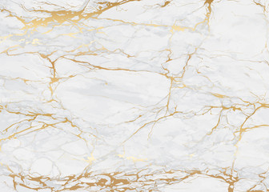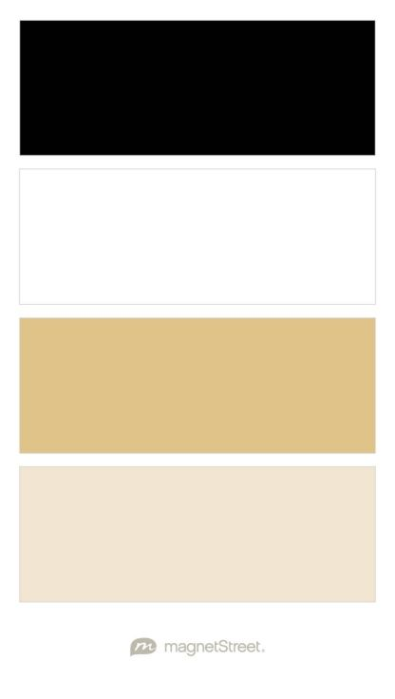

Option 2: blush pink, gold (maybe the marble?), white, black writing

 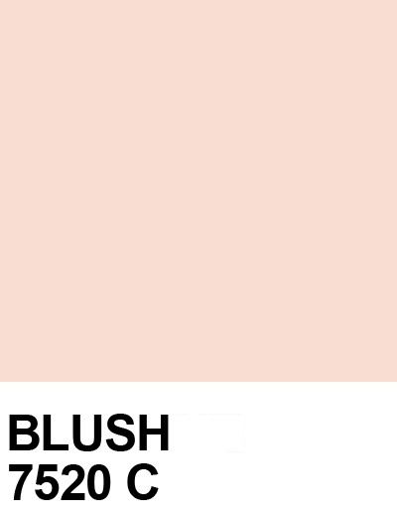

**Option 2: blush pink, gold (maybe the marble?), white, black writing**

 

Option 3: gold, white, green plant tones, black writing



Menu Tab



